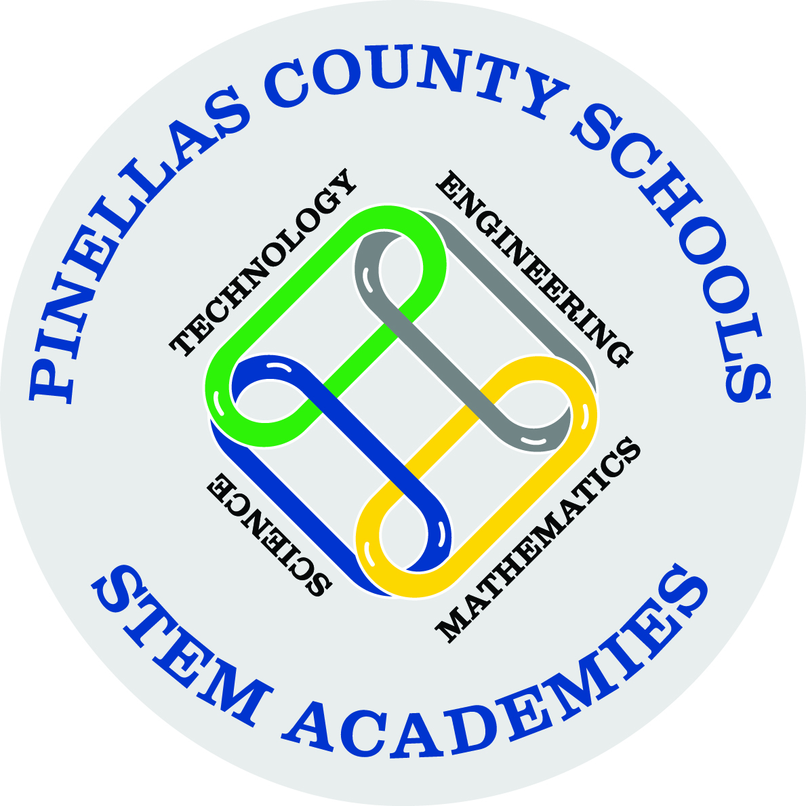

WANT TO BECOME PART OF THE
PCS AFTER SCHOOL STEM ACADEMIES?

Mission: The purpose of the PCS STEM Academies is to increase student achievement by engaging students in innovative science, technology, engineering and math instruction.
Vision: The PCS STEM Academies will provide a continuous pathway of educational opportunities that create students who are globally competitive to accept the challenge of tomorrow’s workforce.
The PCS STEM Academies will offer your child opportunities to conduct hands-on STEM investigations, explore certification/career options, improve teambuilding/leadership skills, learn about the engineering design process, and interact with community business partners!

To learn more about the PCS STEM Academies please visit www.pcsb.org/STEM

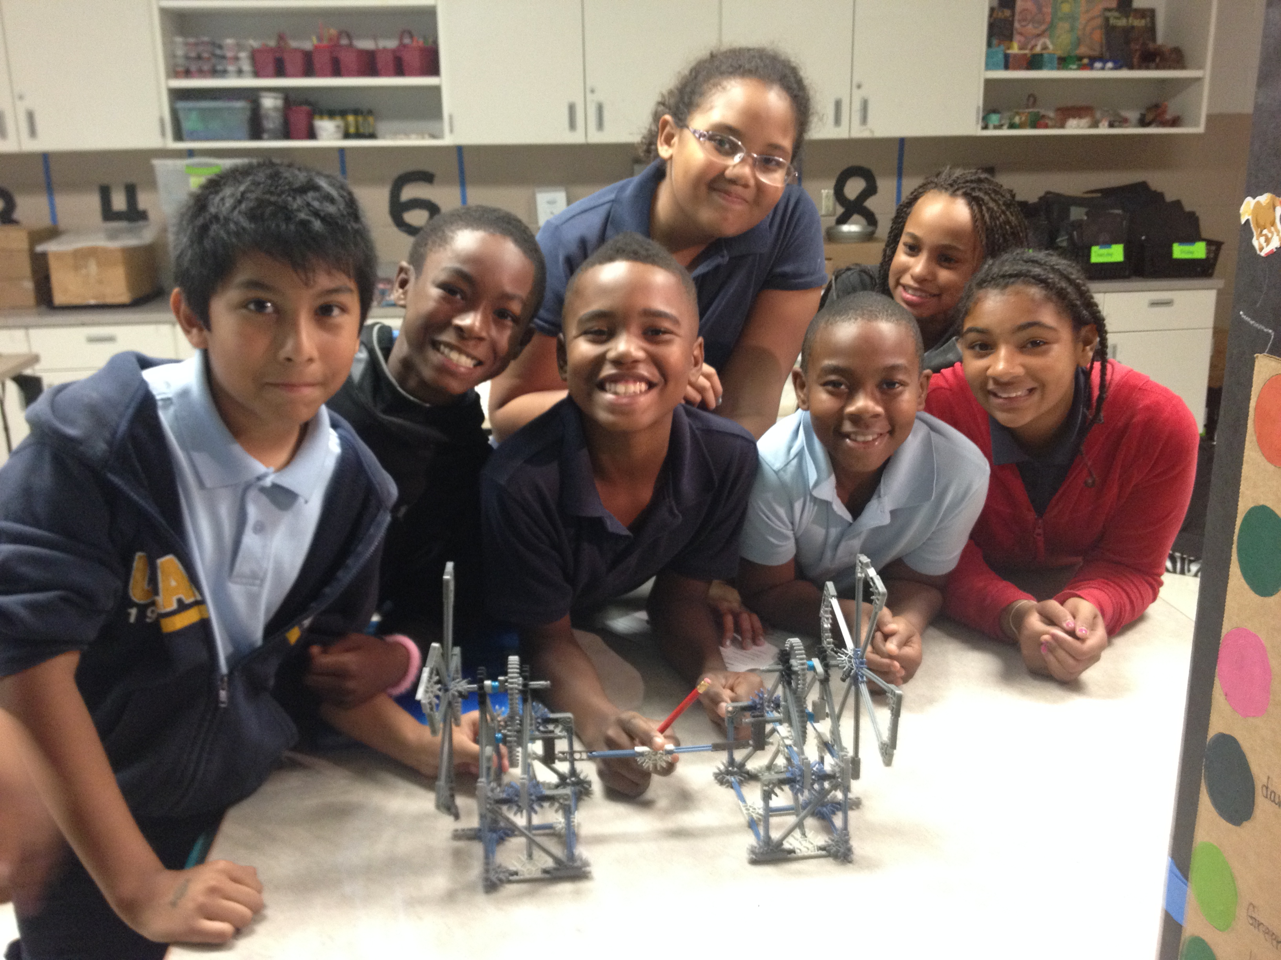
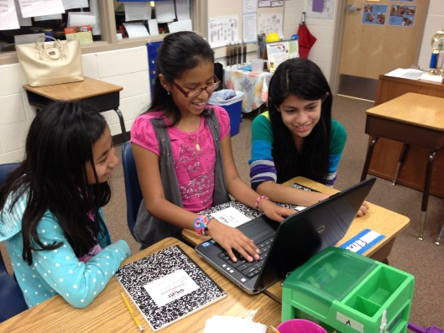
Who?  We are accepting 2nd through 12th grade students. We look for students who work hard and have an interest in STEM concepts. We are selective: just 20 students will be admitted into each after school STEM Academy.  If you were a STEM Academy student last year (2015-2016), you are automatically enrolled as a STEM Academy student for the upcoming 2016-2017 school year when you submit your completed application (pages 3-4).  - Primary STEM Academy = Grades 2nd – 3rd  - Intermediate STEM Academies = Grades 4th – 5th  - Middle Grades STEM Academies = Grades 6th – 8th  - High School STEM Academies = Grades 9th – 12th  When?  This 26-week program will begin during the week of October 3rd and will continue until the last week of April 24th. The Academy at your school’s site will be held on Wednesdays from 2:55pm to 3:55pm.  The Academy will be held at your child’s school site and transportation MUST be provided by the parent/guardian each week. You must wait in the car circle and your child will be escorted out by the STEM Academy Facilitator at Perkins. Please be in the car circle waiting to pick up your child on time.  How?  Fill out the attached application (pages 3-4) and submit the application to your child’s classroom teacher who will then give it to Mrs. Mayhew or Mrs. Ware (the 4th/5th STEM Academy Facilitators) no later than September 9th. Please enter information for every area on the application, especially the email section, as this will be used as the main form of communication to receive STEM Academy updates and opportunities.  After all applications have been submitted, returning STEM Academy students who hand in a completed application will be automatically enrolled. Remaining students will be drawn from a lottery process. Lottery students will be placed into a female and a male pile. Names will be drawn from each pile to ensure that there are approx. 10 females and 10 males in each STEM Academy. If more than 20 students apply, ALL students will be notified if they were selected or if they have been placed on a wait list.  Date handed to student:  August 24th, 2016  Deadline for return of completed application: September 8th, 2016 | What?  During this STEM Academy, students will conduct hands-on activities related to STEM concepts, explore careers in STEM fields, complete a STEM engineering design project and participate in an end-of-the-year STEM Expo on April 29, 2017 at USFSP.  Attendance Requirements  Attendance is a critical component to the success of this program considering the amount of collaborative work among peers. Due to the overwhelming interest in the STEM Academies and the rigor of the planned activities, it is highly suggested that your child tries to attend every session. If your child misses more than 4 unexcused sessions (sick absences will be an exception), he/she will be removed from the Academy and replaced by one of the students on the wait list.  Family Involvement  As a parent/guardian of a STEM Academy student, you will have opportunities to learn more about STEM in Pinellas County through participation in a STEM Academy Family Night. The STEM Family Night will focus on hands-on activities, learning more about the STEM movement in education, as well as explore certification/career pathways for your child in the content areas of STEM (more information to follow). You will also receive an invitation to attend our annual FREE STEM Expo held on April 29, 2017 at USFSP. Last year we had more than 3000 people attend!  Other Information:  If you have questions, please contact the STEM Academy Facilitators at your school:  Mrs. Mayhew mayhewg@pcsb.org (4th/5th)  Mrs. Ware warea@pcsb.org (4th/5th)  If you have any additional questions that your school’s STEM Academy Facilitator cannot answer, please feel free to contact the K-12 STEM Specialist, Laura Spence at Spencela@pcsb.org or (727) 588-6338.
Cost?
This PCS STEM Academy is offered FREE OF CHARGE.

*KEEP PAGES 1-2 AND RETURN PAGE 3 TO YOUR CLASSROOM TEACHER WHO WILL HAND IT INTO THE SCHOOL’S STEM ACADEMY FACILITATOR.
STEM Information
Is your child a returning STEM Academy student from the 2015-2016 school year? YES or NO

If yes, provide the following information:

Grade your child was in last year (2015-2016): ___________
Name of school attended last year: ____________________________
Name of STEM Academy teacher last year: _______________________________

GENERAL INFORMATION
STUDENT NAME (FIRST, LAST)
CLASSROOM TEACHER’S NAME
GRADE CURRENTLY ATTENDING
HOME: STREET ADDRESS
CITY, STATE, ZIP CODE
STUDENT’S GENDER
ETHNICITY (OPTIONAL)
BIRTH DATE (MM/DD/YYYY)
PARENT/GUARDIAN INFORMATION
PRIMARY PARENT/CAREGIVER |  | SECONDARY PARENT/CAREGIVER
RELATIONSHIP TO STUDENT |  | RELATIONSHIP TO STUDENT
STREE ADDRESS  CITY, STATE, ZIP CODE |  | STREET ADDRESS  CITY, STATE, ZIP CODE
CELL NUMBER  HOME NUMBER  WORK PHONE | Cell:  Home:  Work: | CELL NUMBER  HOME NUMBER  WORK PHONE | Cell:  Home:  Work:
EMAIL ADDRESS  *Email addresses will be used to send STEM Academy newsletters and communicate upcoming STEM events. |  | EMAIL ADDRESS  *Email addresses will be used to send STEM Academy newsletters and communicate upcoming STEM events.

I (we), ____________________________, hereby give permission for _________________________ to participate in the STEM Academy.
Parent/Guardian - Print Student’s Name - Print

Our STEM Academy teachers are passionate about your child; however, to honor their time (planning, teaching, family obligations) we ask that students are picked up promptly at the conclusion of each STEM Academy’s session. After 4 late pick-ups, you will be notified that your child will be removed from the program and a new student from the wait list will fill his/her spot.

I (we) acknowledge that I (we) will be responsible for providing pick-up transportation each week for my child.

_________________________________ _____________________
Parent/Guardian Signature Date

